LIT TRAINING

Name: Pataparla Thanusha

Employee ID: 46255251

Q3. **Assignment 3 – Business Add in (BADI)-Single Use**

BADI definition:

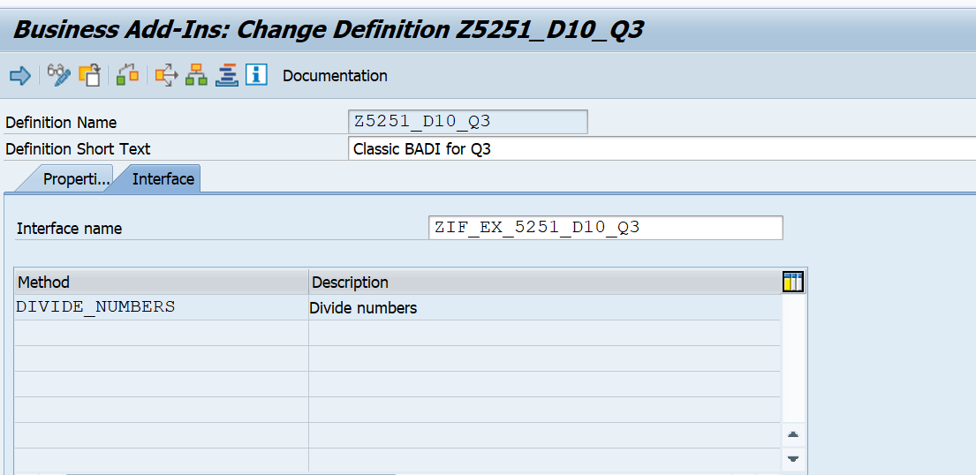

Method parameters:

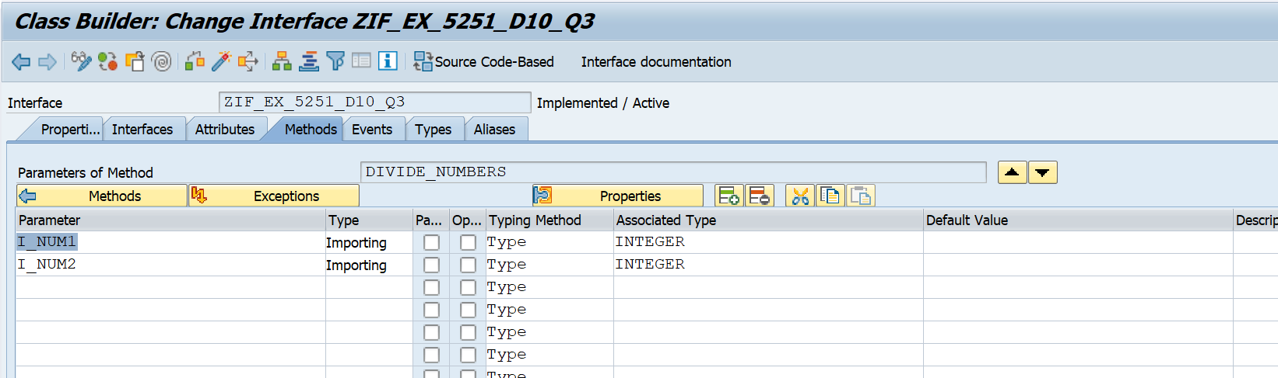

Exception added : CX_SY_ZERODIVIDE

BADI Implementation:

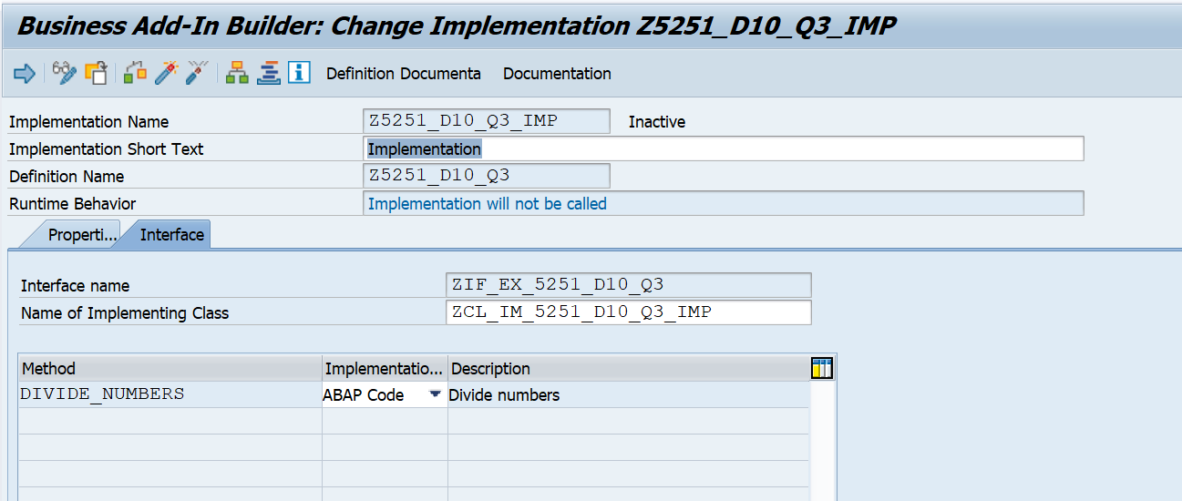

Method implementation:

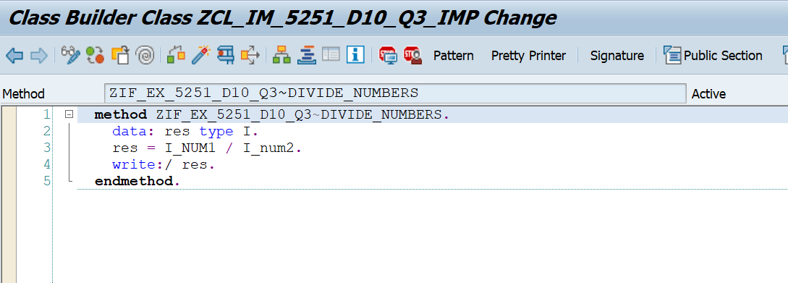

Report:

*&---------------------------------------------------------------------*  
*& Report Z5251_DEMO_BADI  
*&---------------------------------------------------------------------*  
  
REPORT Z5251_DEMO_BADI.  
  
START-OF-SELECTION.  
CLASS CL_EXITHANDLER DEFINITION LOAD.  
  DATA: RES TYPE I.  
  DATA OBJ TYPE REF TO ZIF_EX_BOOKING244.  
  PARAMETERS : I_N1 TYPE I, I_N2 TYPE I.  
  CALL METHOD cl_exithandler=>get_instance  
  EXPORTING exit_name = 'ZBOOKING244'  
* null_instance_accepted = SEEX_FALSE  
* IMPORTING * act_imp_existing =  
CHANGING instance = OBJ  
  EXCEPTIONS no_reference = 1  
    no_interface_reference = 2  
    no_exit_interface = 3  
    class_not_implement_interface = 4  
    single_exit_multiply_active = 5 cast_error = 6  
    exit_not_existing = 7  
    data_incons_in_exit_managem = 8 .  
* others = 9 .  
*IF sy-subrc <> 0. * MESSAGE 'EXIT NOT FOUND' TYPE 'E'. *ENDIF.  
  
TRY.  
CALL METHOD OBJ->DIVIDE_NUMBERS  
  EXPORTING  
    I_NUM1 = I_N1  
    I_NUM2 = I_N2  
    .  
 CATCH CX_SY_ZERODIVIDE .  
ENDTRY.

Selection screen:

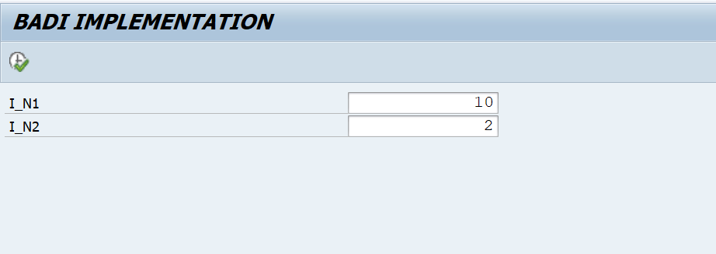

Output:

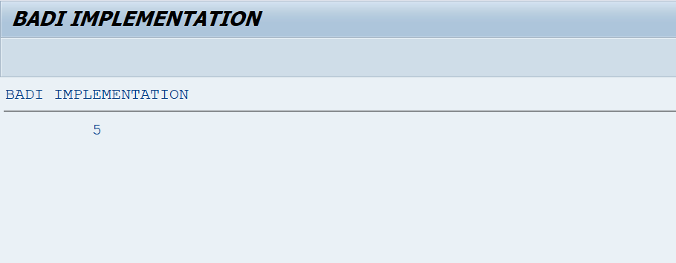

Q4. **Assignment 4 – Business Add in (BADI)-Multiple Use**

BADI definition:

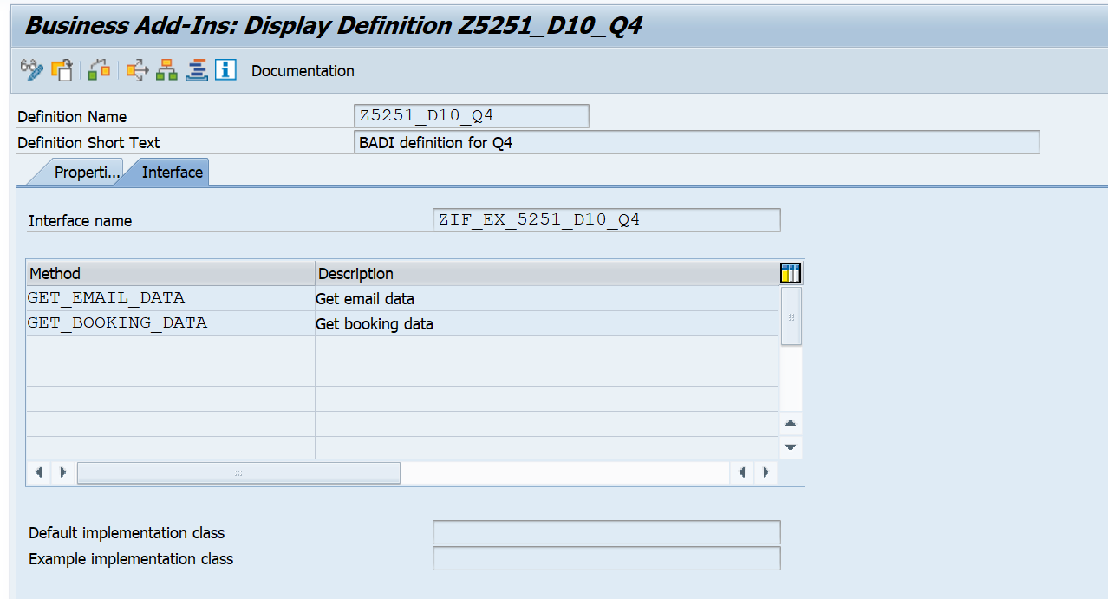

METHODS:

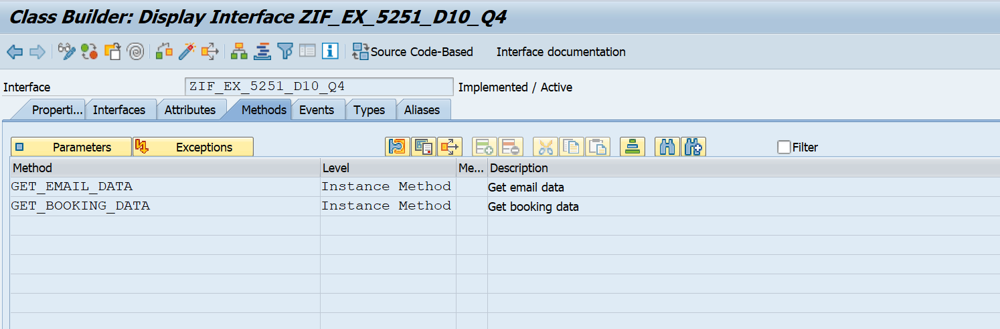

GET_EMAIL_DATA PARAMETERS:

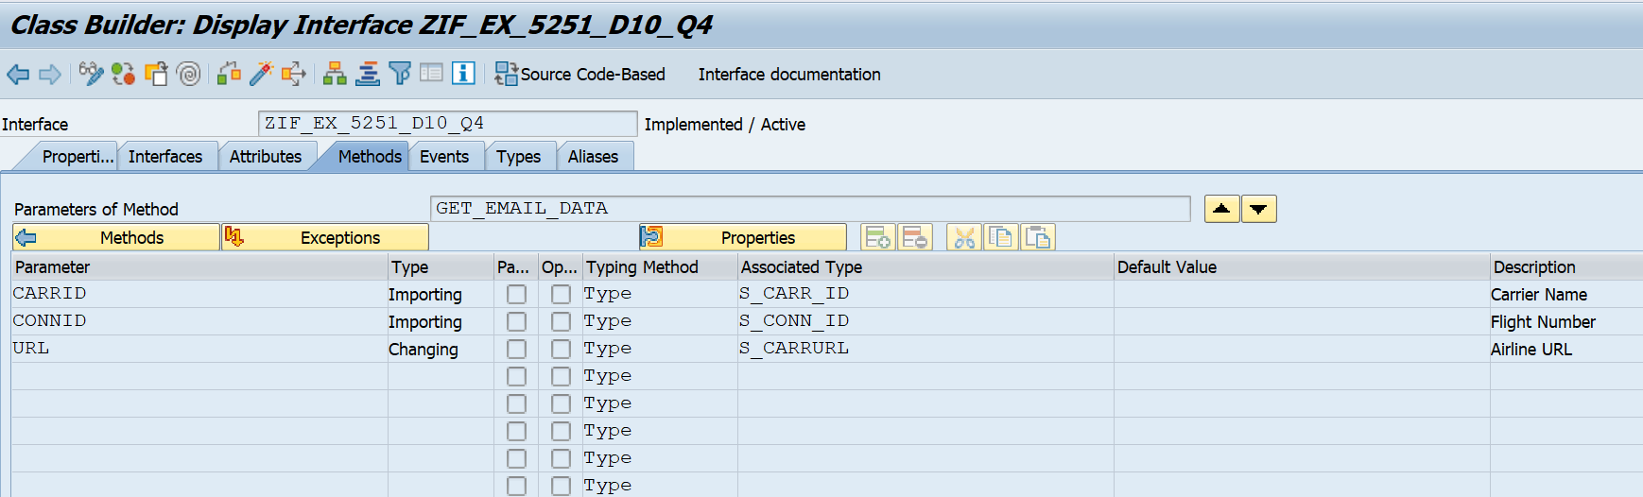

GET_BOOKING_DATA PARAMETERS:

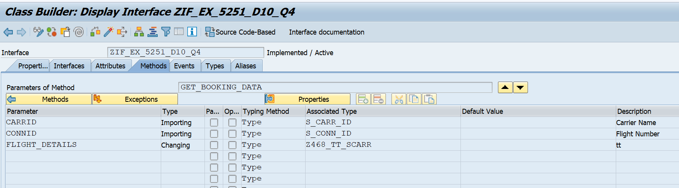

BADI Implementation:

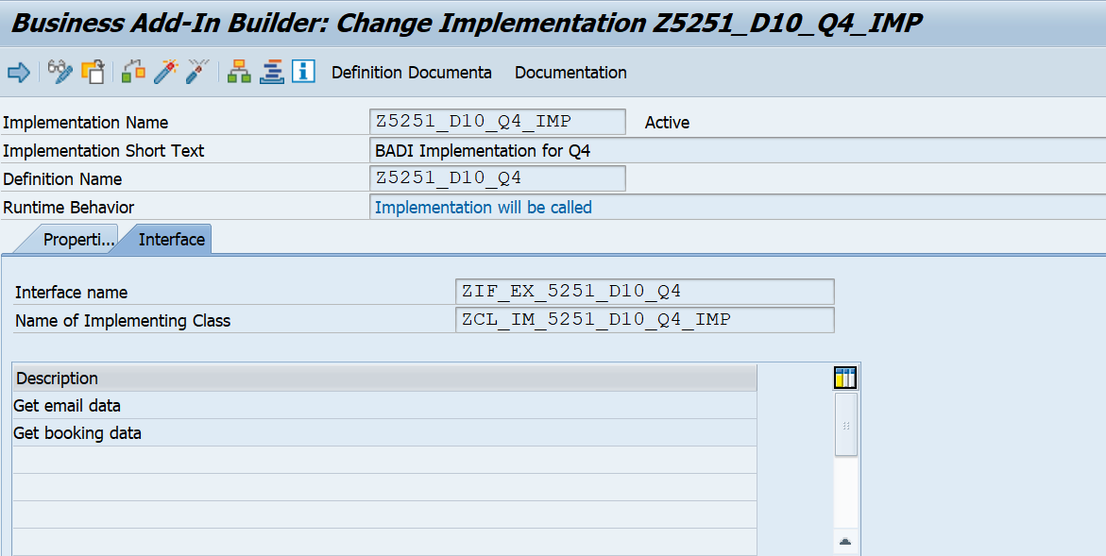

GET_EMAIL_DATA method code:

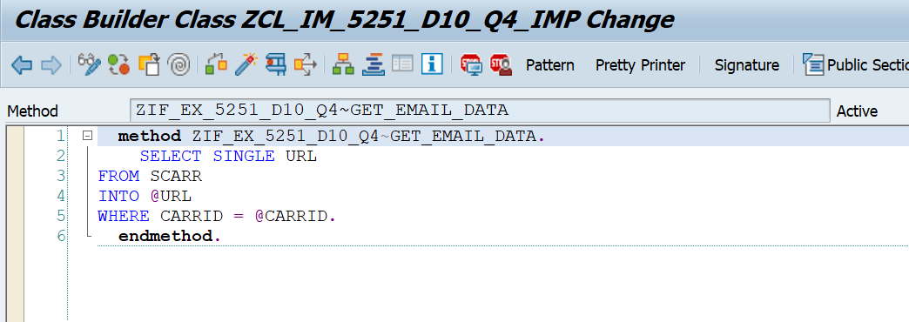

GET_BOOKING_DATA method code:

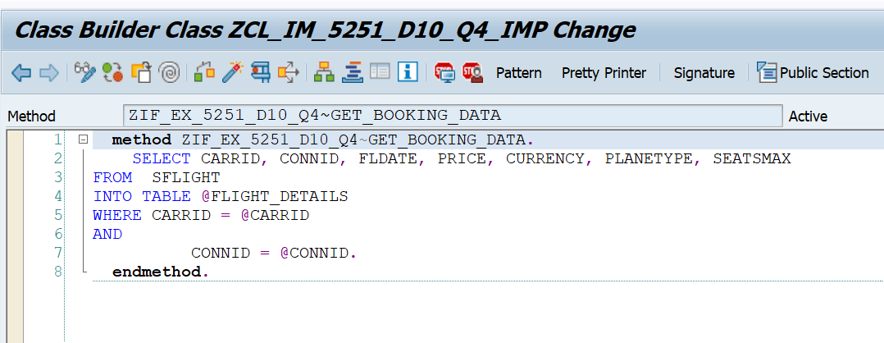

Report:

*&---------------------------------------------------------------------*  
*& Report Z5251_D10_Q4_REPORT  
*&---------------------------------------------------------------------*  
REPORT Z5251_D10_Q4_REPORT.  
  
DATA: VAR TYPE REF TO ZIF_EX_5251_D10_Q4.  
  
PARAMETERS: p_carr TYPE S_CARR_ID,  
            P_flight TYPE S_CONN_ID.  
  
  
DATA : it_flight TYPE  Z468_TT_SCARR,                          " declaring internal table of sflight  
       gs_sflight TYPE line of Z468_TT_SCARR,  
       url type s_carrurl.  
CL_EXITHANDLER=>GET_INSTANCE(  
EXPORTING  
    EXIT_NAME                     =  'Z5251_D10_Q4'   " Business Add-In Definition  
*    NULL_INSTANCE_ACCEPTED        =     " Is Null Instance OK if There Is no Active Implementation?  
*  IMPORTING  
*    ACT_IMP_EXISTING              =     " Returns an Active Implementation  
CHANGING  
    INSTANCE                      =  var   " Instance  
EXCEPTIONS  
    NO_REFERENCE                  = 1  
    NO_INTERFACE_REFERENCE        = 2  
    NO_EXIT_INTERFACE             = 3  
    CLASS_NOT_IMPLEMENT_INTERFACE = 4  
    SINGLE_EXIT_MULTIPLY_ACTIVE   = 5  
    CAST_ERROR                    = 6  
    EXIT_NOT_EXISTING             = 7  
    DATA_INCONS_IN_EXIT_MANAGEM   = 8  
OTHERS                        = 9  
).  
IF SY-SUBRC <> 0.  
* MESSAGE ID SY-MSGID TYPE SY-MSGTY NUMBER SY-MSGNO  
*            WITH SY-MSGV1 SY-MSGV2 SY-MSGV3 SY-MSGV4.  
ENDIF.  
  
  
CALL METHOD VAR->GET_BOOKING_DATA  
  EXPORTING  
    CARRID         = p_carr  
    CONNID         = p_flight  
  CHANGING  
    FLIGHT_DETAILS = it_flight  
    .  
  
IF SY-SUBRC <> 0.  
* MESSAGE ID SY-MSGID TYPE SY-MSGTY NUMBER SY-MSGNO  
*            WITH SY-MSGV1 SY-MSGV2 SY-MSGV3 SY-MSGV4.  
ENDIF.  
  
*TRY.  
CALL METHOD VAR->GET_EMAIL_DATA  
  EXPORTING  
    CARRID = p_carr  
    CONNID = p_flight  
  CHANGING  
    URL    = url  
    .  
* CATCH CX_VBC_NOT_FOUND .  
*ENDTRY.  
  
  
  
WRITE: / 'Airline URL is' COLOR COL_POSITIVE,  url.  
WRITE: 40 'Flight Details' COLOR COL_POSITIVE.  
WRITE: / 'CARRID',  
10 'CONNID',  
20 'FLDATE',  
31 '      PRICE',  
52 'CURRENCY',  
63 'PLANETYPE',  
75 'SEATSMAX'.  
ULINE.  
LOOP AT it_flight INTO gs_sflight.  
WRITE : /  gs_sflight-carrid LEFT-JUSTIFIED,  
10 gs_sflight-connid,  
20 gs_sflight-fldate,  
31 gs_sflight-price,  
52 gs_sflight-currency,  
63 gs_sflight-planetype,  
75 gs_sflight-seatsmax.  
ENDLOOP.

Selection screen:

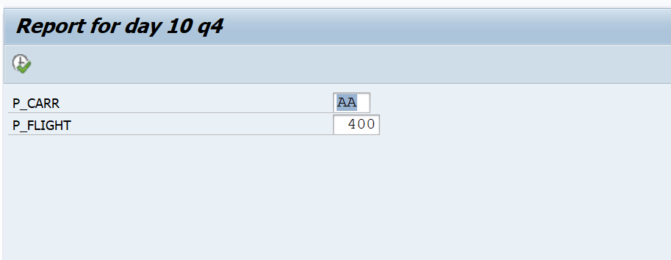

Flight details:

